**Year 12 ATAR PHYSICS**

**Practical Test WAVES AND QUANTA**

**Part B: DETERMINING THE EFFECTIVE WAVELENGTH OF A LED.**

**Marks: /10**

**ANSWERS**

The threshold voltage at which a semiconductor LED turns on gives a measure of the bandgap or emission wavelength of the LED through the following relationship:



**The following circuit was constructed:**

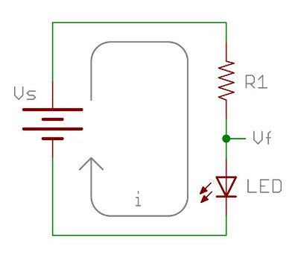

V

100 Ω resistor

50K Rheostat

A

By adjusting the rheostat, the following values of current and voltage through the LED was recorded:

|  |  |
| --- | --- |
| *V(V)* | *I(mA)* |
| 2.40 | 0.12 |
| 2.43 | 0.40 |
| 2.44 | 0.50 |
| 2.48 | 0.97 |
| 2.50 | 1.20 |

**Question 1**

Plot a suitable graph of the results. **( 4 marks)**

1. **Labels (1) appropriate scales (2) accurate plotting (-1 if scale inappropriate and LOBF too steep)**

**mA**

1.2

1.1

1.0

0.9

0.8

0.7

0.6

0.5

0.4

0.3

0.2

0.1

0

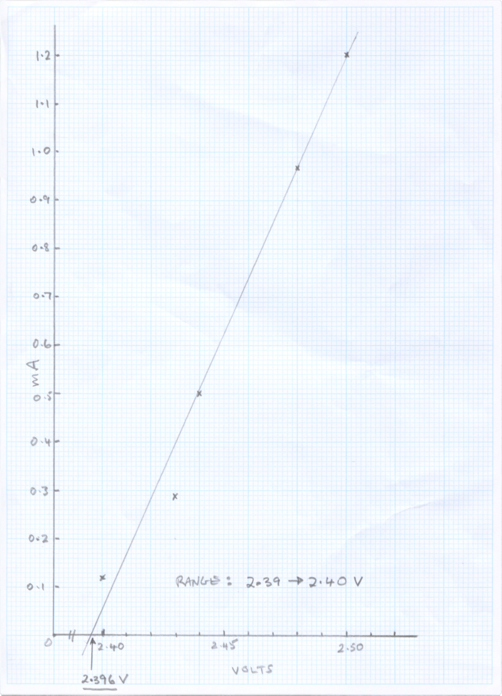

**x**

**x**

**x**

**x**

**x**

**Range: 2.39 - 2.42**

2.40 2.45 2.50

**2.395**

**Question 2 ( 3 marks)**

Determine the threshold voltage **from the graph**. **Clearly show** your method on the graph.

**(1) Method shown**

**Vth = 2.39V to 2.42V (1) (0 above or below)**

**Answer to 3 or 4 sig figs (1)**

**Question 3 ( 3 marks)**

Determine the wavelength of the LED in nanometres.

 = hc / eVth

*= 6.63 x 10-34 . 3 x 108* **(1)**

*1.6 x 10 -19 .* ***2.395***

*= 5.19 x 10-7 m*

*= 5.19 x 102 nm (3 sig figs)*

1. **(1)**

*Note for example: 519nm 3 sig fig OK*

*520 nm only 2 sig fig -1*